Best Cities To Live in the USA

Shruti Goel
Computer Science
New York, USA
sg4224@nyu.edu
Prachee Mhatre
Computer Science
New York, USA
phm265@nyu.edu

Sreerupa Nandi
Computer Science
New York, USA
sn1744@nyu.edu

Abstract—
In this research work we have measured various cities and towns in the United States based on livability conditions to find the most livable ones. We have analyzed data across over 300 cities to come up with absolute rankings in terms of the deciding factors. We have initially come up with some basic rankings without equal weight across all the factors. We have then further extended our studies by assigning appropriate weights to the factors and presented the ten most livable cities across the nation.

Introduction
From metros to small towns we have compared over 300 cities across the United States to find out the most livable. We have consulted quite a few criteria pertaining to livability including public safety, environment-friendliness, economy, healthcare infrastructure, climatic conditions, housing conditions, educational infrastructure, transport system, etc. We have first found out the raw rankings of the cities based on even weights across all the livability criteria and then we have further realized our study by assigning varied weights to the different criteria by consulting experts. We have based our analysis mainly on historical data collected over the last few years by various agencies. The study has led to a concrete result of top ten cities that are ideal to move in the next couple of years.

Motivation
For some Americans, the cultural vibrancy of New York seems appealing, some prefer the dramatic landscapes of San Francisco; however a greater population probably would like to spend the bigger half of their lives in a comparatively smaller city. A vast number of agencies have conducted surveys across millions of people to find out their preferred choices. However, surveys do not always convey the actual information based on facts. The cultural spectrum of New York might be magnetic but it is also the most expensive city to live in the country with average household income ranging above $50,000.
While most of the people plan to move to their dream cities, they are less aware of the various livability standards associated with them. Low crime rate, good healthcare systems, greenery, affordable housing conditions – these are some of the basic criteria that decide the livability index of a city. With our analytics based on several deciding factors, it will be easier for common men with little or no knowledge of the livability conditions of cities hundreds of miles away, to plan their next move.

Related Work
There have been various surveys and studies conducted by agencies the country. However we have referred to quite a few number of studies related our project work. For example in Quality of Life and City Competitiveness ^{[5]} by Robert J. Rogerson, the author has focused on all the life factors which are usually influential in patterns of urban growth and development. The most traditional way to calculate the city competiveness is to calculate the quality of life in those cities. The ideas for quality of life could be used for city promotion and also in city marketing. Although at the centre the idea still remains that quality of life evaluation should focus on the personal satisfaction and happiness of the people who live there.
In Urban Landscapes and Sustainable Cities. Ecology and society ^{[6]} by Erik Andersson, the author has mentioned that the relation between ecological characteristics and the ecosystems services people enjoy to live in cities is incompletely understood. Since urban development is run by human values, there is a requirement to inform people about the ecological requirements for the ecosystem services that increase human well-being. Thus we have considered ecological characteristics in our studies as well.
We have referred to Absolute and relative measurement with the AHP. The most livable cities in the United States ^{[7]} by Thomas L. Saaty to shape our ranking process. Ranking can be both absolute and relative. Since we are mainly measuring tangible attributes we have limited our study to absolute comparisons, where an individual entity is compared an already established standard. The author has referred to Places Rated Almanac by Rand McNally where absolute measurement has been used to rank various cities across the United States based on different livability criteria such as climate, housing, healthcare, crime, transportation, education, arts, recreation, economics.

Design

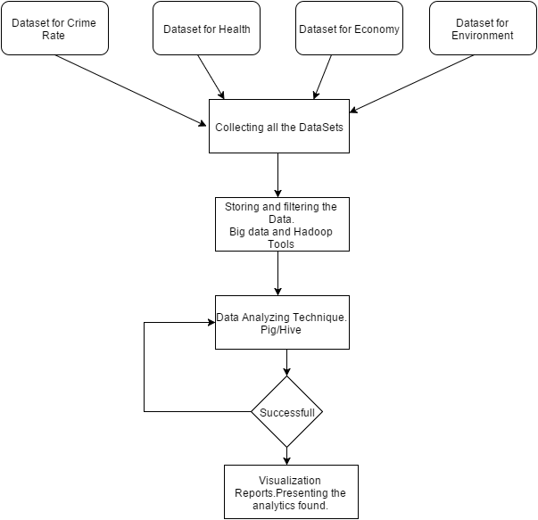

Results
()

Future Work
()

Conclusion
()

Acknowledgment
()

References

- T. White. Hadoop: The Definitive Guide. O’Reilly Media Inc., Sebastopol, CA, May 2012.
- A. Gates. Programming Pig. O’Reilly Media Inc.,Sebastopol, CA, October 2011.
- J. Dean and S. Ghemawat. MapReduce: Simplified data processing on large clusters. In proceedings of 6th Symposium on Operating Systems Design and Implemenation, 2004.
- S. Ghemawat, H. Gobioff, S. T. Leung. The Google File System. In Proceedings of the nineteenth ACM Symposium on Operating Systems Principles – SOSP ‘03, 2003
- Robert J. Rogerson. Quality of Life and City Competitiveness. Urban Studies, Vol. 36, Nos 5-6, 969-985, 1999
- Erik Andersson. Urban Landscapes and Sustainable Cities. Ecology and society. 11:1, 34 [Journal article]
- Thomas L. Saaty. Absolute and relative measurement with the AHP. The most livable cities in the United States. Socio-Economic Planning Sciences, Volume 20, Issue 6, 1986, Pages 327–331

